Practical No 18

VIII. Resources required (Additional)
→ If any web resources required.

Resources used (Additional)
→ https://docs.microsoft.com/en-us/dotnet/visual-basic/language- reference/statements/function-statement
→ https://www.tutorialspoint.com/vb.net/vb.net_functions.htm

Program Code
  - Write a program to demonstrate the use of constructor & destructor.
- A) Constructor- Module Module1 Sub Main()
Dim obj As New syco obj.show() Console.ReadLine()
End Sub
Public Class syco
Public Function show() Console.WriteLine("This is base class")
End Function Sub New()
Console.WriteLine("Constructor Executed") End Sub
End Class End Module

OUTPUT:
Constructor Executed This is base class

Module Module1 Sub Main()
Dim obj As New syco obj.show()
End Sub End Module
Public Class syco
Public Function show() Console.WriteLine("This is base Class")
End Function
Protected Overrides Sub Finalize() Console.WriteLine("Destructor executing here") Console.ReadLine()
End Sub End Class

OUTPUT:
This is base class Destructor executing here

- Results (output of the program)
- Constructor Executed This is base class
- This is base class Destructor executing here

- Practical related Questions
  - Find output in following code.
➢ 40

Find Error in following code.
Imports System.Console Module Module1
Sub Main()
Dim obj As New Destroy() End Sub
End Module
Public Class Destroy
Protected Overrides Finalize()
Write(“VB.NET”)
Read() End Sub
End Class
- Error 1 'Overrides' is not valid on a member variable declaration.
Warning 2 variable 'Finalize' conflicts with sub 'Finalize' in the base class 'Object' and should be declared 'Shadows'.
Error 3 Declaration expected. Error 4 Declaration expected.
Error 5 'End Sub' must be preceded by a matching 'Sub'.

rcise
  - Implement a program to display any message at run time.(Using Constructor).
- Module Module1
Sub Main()
Dim obj As New sample obj.display() Console.ReadLine()
End Sub

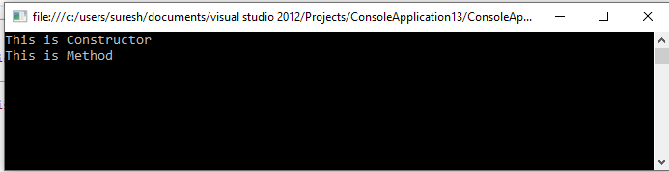
Class sample
Public Sub New()
Console.WriteLine("This is Constructor") End Sub
Sub display()
Console.WriteLine("This is Method") End Sub
End Class End Module

Output:

Implement a program to calculate area of circle using parameterized constructor.
- Module Module1
Sub Main()
Dim obj As New circle(2) obj.area() Console.ReadLine()
End Sub Class circle
Dim p As Double = 3.14 Dim r, a As Double
Public Sub New(ByVal i As Integer) r = i
End Sub Sub area()
a = p * r * r
Console.WriteLine("Area of Circle = " & a) End Sub
End Class End Module

OUTPUT:
Area of Circle = 12.56

